Bank Loan Project Query Document
Bank Loan Report: Summary
KPI’s:
1.Total Loan Applications:
Select count(id) as Total_Loan_Applications From bank_loan_data;
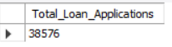
MTD Loan Applications:
Select count(id) as MTD_Total_Loan_Applications From bank_loan_data Where month(issue_date) = 12 And year(issue_date) = 2021;
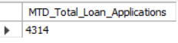
PMTD Loan Applications:
Select count(id) as PMTD_Total_Loan_Applications From bank_loan_data Where month(issue_date) = 11 And year(issue_date) = 2021;
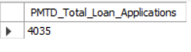

2.Total Funded Amount:
Select sum(loan_amount) as Total_Funded_Amount From bank_loan_data;
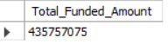

MTD Total Funded Amount:
Select sum(loan_amount) as MTD_Total_Funded_Amount From bank_loan_data where month(issue_date) = 12 and year(issue_date) = 2021;
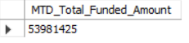
PMTD Total Funded Amount:
Select sum(loan_amount) as PMTD_Total_Funded_Amount From bank_loan_data where month(issue_date) = 11 and year(issue_date) = 2021;
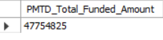

3.Total Amount Received:
Select sum(total_payment) as Total_Amount_Received From bank_loan_data;
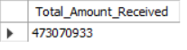
MTD Total Amount Received:
Select sum(total_payment) as MTD_Total_Amount_Received From bank_loan_data where month(issue_date) = 12 and year(issue_date) = 2021;
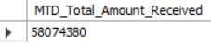
PMTD Total Amount Received:
Select sum(total_payment) as PMTD_Total_Amount_Received From bank_loan_data where month(issue_date) = 11 and year(issue_date) = 2021;
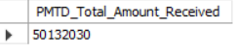

4.Average Interest Rate:
Select Round(Avg(int_rate),5) * 100 as Average_Interest_Rate From bank_loan_data;
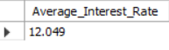
MTD Average Interest Rate:
Select Round(Avg(int_rate),5) * 100 as MTD_Average_Interest_Rate From bank_loan_data where month(issue_date) = 12 and year(issue_date) = 2021;
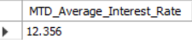
PMTD Average Interest Rate:
Select Round(Avg(int_rate),5) * 100 as PMTD_Average_Interest_Rate From bank_loan_data where month(issue_date) = 11 and year(issue_date) = 2021;
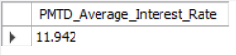

5.Average Debt To Income Ratio(DTI):
Select Round(Avg(dti),4) * 100 as Average_DTI From bank_loan_data;
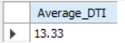

MTD Average Debt To Income Ratio(DTI):
Select Round(Avg(dti),5) * 100 as MTD_Average_DTI From bank_loan_data where month(issue_date) = 12 and year(issue_date) = 2021;
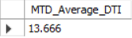
PMTD Average Debt To Income Ratio(DTI):
Select Round(Avg(dti),5) * 100 as PMTD_Average_DTI From bank_loan_data where month(issue_date) = 11 and year(issue_date) = 2021;
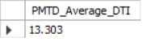

Good Loan Vs Bad Loan KPI’s
Good Loan KPI’s:
1.Good Loan Application Percentage:
SELECT round((count(case when loan_status = 'Fully Paid' or loan_status = 'Current' then id end)*100)
/
count(id),2) As Good_Loan_Percentage
FROM bank_loan_data;
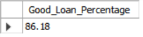
2.Good Loan Applications:
SELECT COUNT(id) AS Good_Loan_Applications FROM bank_loan_data WHERE loan_status = 'Fully Paid' OR loan_status = 'Current';
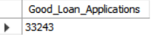
3.Good Loan Funded Amount:
SELECT SUM(loan_amount) AS Good_Loan_Funded_Amount FROM bank_loan_data WHERE loan_status = 'Fully Paid' OR loan_status = 'Current';
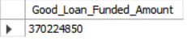
4.Good Loan Total Received Amount:
SELECT SUM(total_payment) AS Good_Loan_Received_Amount FROM bank_loan_data WHERE loan_status = 'Fully Paid' OR loan_status = 'Current';
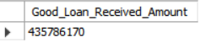

Bad Loan KPI’s
1.Good Loan Application Percentage:
SELECT round((count(case when loan_status = 'Charged Off' then id end)*100)
/
count(id),2) As Bad_Loan_Percentage
FROM bank_loan_data;
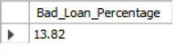
2.Bad Loan Applications:
SELECT COUNT(id) AS Bad_Loan_Applications FROM bank_loan_data WHERE loan_status = 'Charged Off';
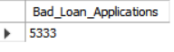
3.Bad Loan Funded Amount:
SELECT SUM(loan_amount) AS Bad_Loan_Funded_Amount FROM bank_loan_data WHERE loan_status = 'Charged Off';
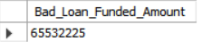
4.Bad Loan Total Received Amount:
SELECT SUM(total_payment) AS Bad_Loan_Received_Amount FROM bank_loan_data WHERE loan_status = 'Charged Off';
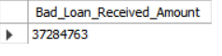

Loan Status Grid View:
SELECT loan_status,
COUNT(ID) AS Total_Loan_Applications,
SUM(loan_amount) As Total_Funded_Amount,
SUM(total_payment) AS Total_Received_Amount,
AVG(int_rate * 100) AS Average_Interest_Rate,
AVG(dti * 100) AS Average_Debt_To_Income_Ratio
FROM bank_loan_data
GROUP BY loan_status; 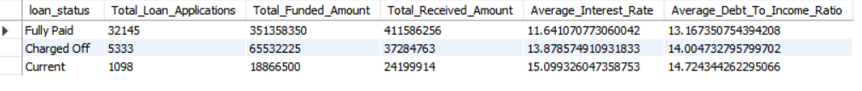
MTD Loan Status Grid View:
SELECT loan_status,
SUM(loan_amount) As MTD_Total_Funded_Amount,
SUM(total_payment) AS MTD_Total_Received_Amount
FROM
bank_loan_data WHERE month(issue_date) = 12
GROUP BY loan_status;
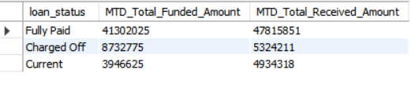
PMTD Loan Status Grid View:
SELECT loan_status,
SUM(loan_amount) As PMTD_Total_Funded_Amount,
SUM(total_payment) AS PMTD_Total_Received_Amount
FROM
bank_loan_data WHERE month(issue_date) = 11
GROUP BY loan_status;
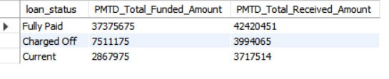

Bank Loan Report: Overview
1.Monthly Trends by Issue Date (Line Chart):
SELECT
MONTH(issue_date) AS Month_Number,
MONTHNAME(issue_date) AS Month_Name,
COUNT(id) AS Total_Applications,
SUM(loan_amount) AS Total_Funded_Amount,
SUM(total_payment) AS Total_Received_Amount
FROM bank_loan_data
GROUP BY MONTH(issue_date),MONTHNAME(issue_date)
ORDER BY MONTH(issue_date);
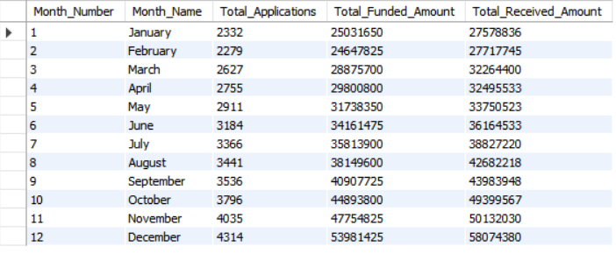
2. Regional Analysis by State (Filled Map):
SELECT
address_state AS Region,
COUNT(id) AS Total_Applications,
SUM(loan_amount) AS Total_Funded_Amount,
SUM(total_payment) AS Total_Received_Amount
FROM bank_loan_data
GROUP BY address_state
ORDER BY address_state;
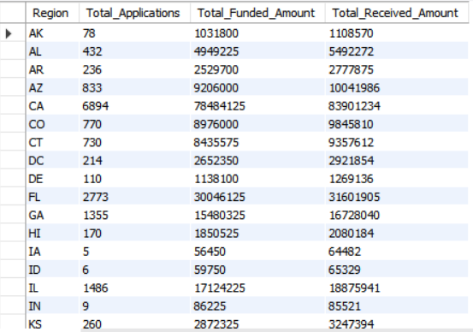
3. Loan Term Analysis (Donut Chart):
SELECT
Term AS Loan_Term,
COUNT(id) AS Total_Applications,
SUM(loan_amount) AS Total_Funded_Amount,
SUM(total_payment) AS Total_Received_Amount
FROM bank_loan_data
GROUP BY Term
ORDER BY Term;
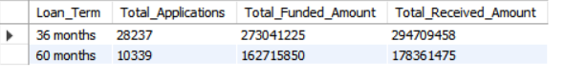

4. Employee Length Analysis (Bar Chart):
SELECT
emp_length AS Employee_Length,
COUNT(id) AS Total_Applications,
SUM(loan_amount) AS Total_Funded_Amount,
SUM(total_payment) AS Total_Received_Amount
FROM bank_loan_data
GROUP BY emp_length
ORDER BY emp_length;
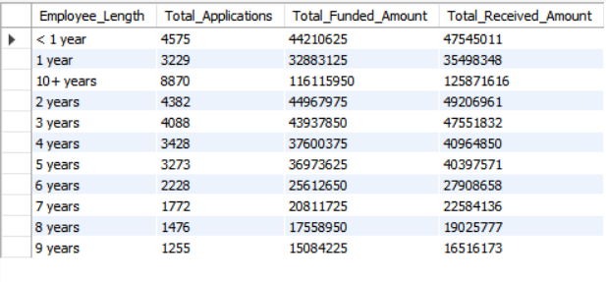
5. Loan Purpose Breakdown (Bar Chart):
SELECT
purpose AS Loan_Purpose,
COUNT(id) AS Total_Applications,
SUM(loan_amount) AS Total_Funded_Amount,
SUM(total_payment) AS Total_Received_Amount
FROM bank_loan_data
GROUP BY purpose
ORDER BY COUNT(id) DESC;
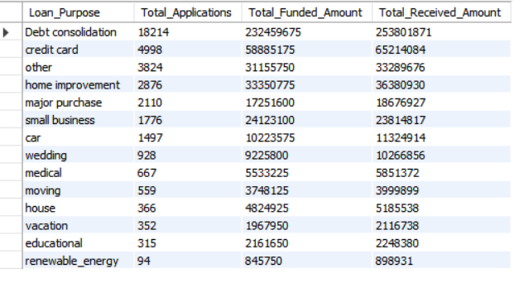
6. Home Ownership Analysis (Tree Map):
SELECT
home_ownership AS home_ownership,
COUNT(id) AS Total_Applications,
SUM(loan_amount) AS Total_Funded_Amount,
SUM(total_payment) AS Total_Received_Amount
FROM bank_loan_data
GROUP BY home_ownership
ORDER BY COUNT(id) DESC;
